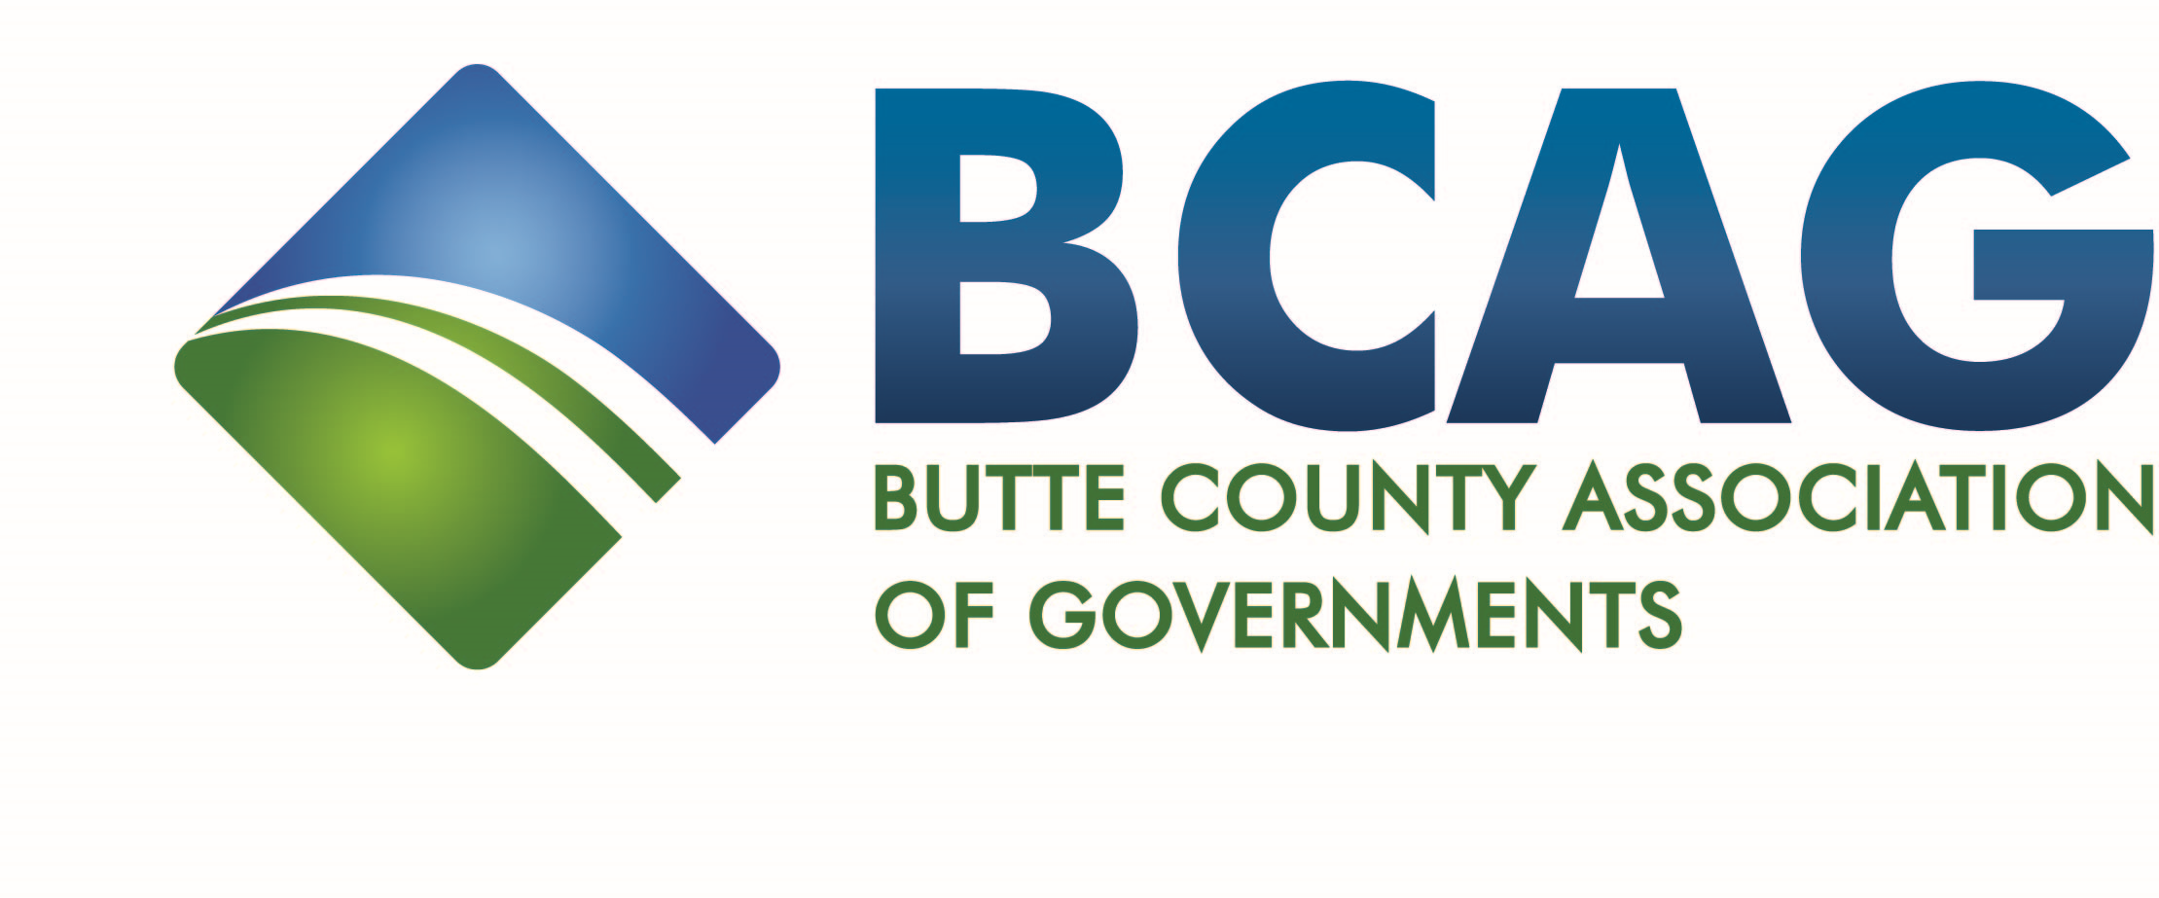
326 Huss Drive, Suite 150
Chico, California 95928
(530) 809-4616 FAX (530) 879-2444

NOTICE OF CANCELLATION
The Butte County Association of Governments
January 26, 2023
Board of Director’s Meeting
HAS BEEN CANCELLED
The next Board of Director’s Meeting
will be held on
Thursday, February 23, 2023 at 9:00 A.M.
at the
BCAG BOARD ROOM
326 Huss Drive, Suite 100
Chico, CA 95928

